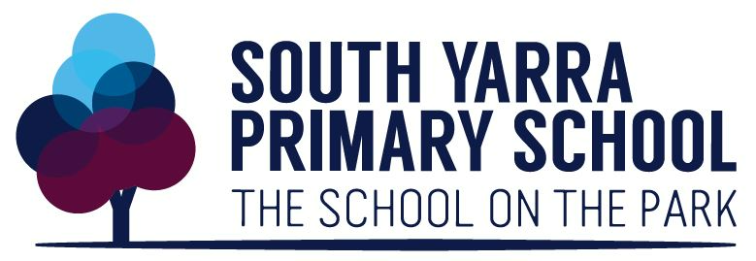
Bus Safety Policy

South Yarra Primary School is committed to providing and maintaining a safe and healthy workplace for all staff and students, including travel for work. Hazards and risks to health and safety will be eliminated or minimised, as far as is reasonably practicable South Yarra Primary School is also committed to implementing systems and processes that reflect the appropriate level of risk at any given time.
Principals or their delegate will:

- ensure South Yarra Primary School complies with all legislation relating to health and safety
- eliminate or minimise workplace hazards and risks so far as reasonably practicable
- provide information, instruction, and training to enable all staff to work safely
- supervise staff to ensure work activities are performed safely
- consult with and involve staff on matters relating to health and safety
- provide safety equipment and personal protective equipment, where required
- provide a suitable injury management and return to work program.
Staff will:
- take reasonable care for their own health and safety
- follow safe work procedures, instructions and rules
- participate in safety training
- report health and safety hazards and incidents on eduSafe Plus and to Safe Transport Victoria if required
- use safety equipment and personal protective equipment as instructed
- be familiar with the school’s emergency management plan for bus transport.
School bus drivers will adhere to the department’s Work-Related Driving policy by:
- complying with the Victorian Road rules
- not consuming drugs, alcohol and/or medications that might affect their ability to drive safely, and complying with drug and alcohol laws at all times
- avoiding the unsafe use of mobile devices and other technologies
- managing fatigue and avoiding distractions
- wearing a seatbelt and ensuring passengers are wearing seatbelts
- not exceeding the maximum seating capacity of the bus
- reporting all incidents/accidents in eduSafe and to Safe Transport Victoria.
School bus drivers will also adhere to the No Child Left on Bus Duty procedure, which forms part of this Bus Safety policy.

No Child Left on Bus Duty

South Yarra Primary School requires all staff who drive the bus or supervise students on the bus to perform the school’s No Child Left on Bus Duty (NCLB Duty).
South Yarra Primary School will incorporate the NCLB Duty in staff driver training, including how to conduct and record post-trip bus inspections to ensure no child is left on the bus.
The NCLB Duty for staff comprises the following:
- A roll of children travelling on a bus trip is provided by the school to the driver (or supervising staff member if present).
Before each trip/leg of bus travel:
- The driver (or supervising staff member) will check off the students on the roll to confirm that all students listed on the roll have boarded the bus before departure.
After each trip/leg of bus travel:
- At the end of the trip/leg, the driver and/or supervising staff member will walk the full length of the bus, inspecting on and under seats to check that no students remain on the bus after the students have disembarked the bus.
- The driver and/or supervising staff member records on the roll that the bus has been checked and that all students have disembarked the bus.
South Yarra Primary School will keep the bus rolls on file in a secure location at the school as a record that all children boarded and disembarked the bus at the correct location/s, and that the bus was inspected to ensure no child was left on the bus. The bus rolls will be retained for 5 years as per the department’s records management policy.

This policy was accepted by South Yarra Primary School in: April 2026
This policy was last reviewed in: April 2026

Name: Neven Paleka, Principal and South Yarra Junior School Council Members

